GAUGE 1 MODEL RAILWAY ASSOCIATION – STANDARD DIMENSIONS

1 – RAIL PROFILES:

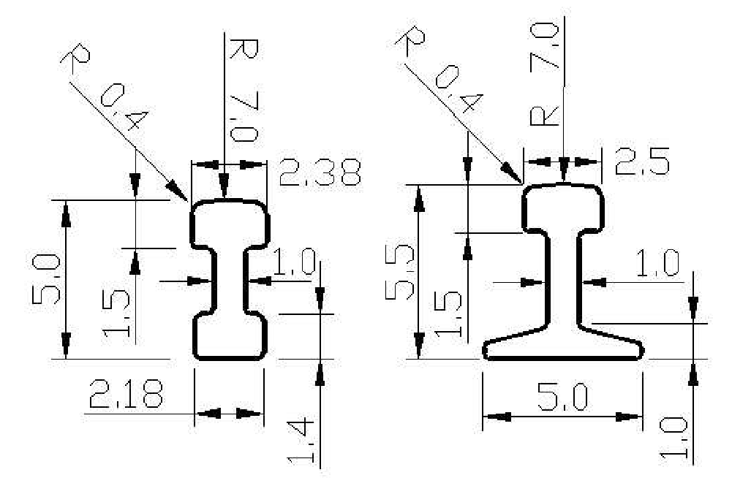
Bullhead rail profile Flat Bottom rail profile

– TRACK SPACING British outline – Centre to Centre

Straight running lines -115mm minimum
Curved running lines, under 3650mm radius,
- 120mm minimum
Curved running lines, under 2450mm radius,
-125mm minimum
Straight sidings -120mm minimum

Supplement to G1MRA standards – suggested track spacing for non-British stock.

As a result of input from members who run nonBritish outline stock, we suggest the following centre line spacing as a starting point:

Parallel track - 135mm tolerance -0/+10mm
Curves (tight) - 148mm tolerance -0/+12mm
Curves - 140mm tolerance -0/+15mm

Trackbed area, clear of obstructions (to avoid footsteps etc) 68mm from centre line on curves 60mm on straights.

Stock Gauge – depending on stock but 232mm high will just allow American “Double-Stack Container cars” through. Allow extra side clearance in curved tunnels etc.

– ELECTRIC PICK-UP

Conductor rail –

Height above running rail (top) – 3.0mm
Centre from inside edge of running rail – 14.00mm
Overhead line - Proposed Standards

Height of contact wire above rail – 160mm tolerance -10/+20
Maximum offset from centre line of track 12.5mm

Stud Contact

Skate dimensions. Allow 3.2mm rise at ends
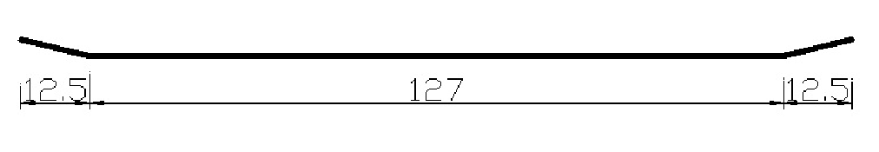
 | Standard |  | Fine
Skate width | 20 | mm | 12.5 | mm
Studs:
Maximum spacing | 114 | mm | 114
Maximum height above  rails | 1.6 | mm | 1.6 | mm
Maximum rise between adjacent studs | 1.6 | mm | 1.6 | mm
Maximum offset from centre – line of track at turnouts | 8 | mm | 4.8 | mm

– BUFFERS AND COUPLINGS

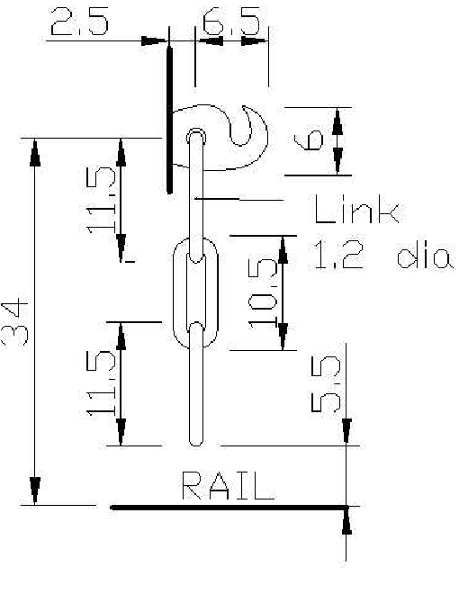

Buffers Height
above rail - 35mm

Centres - 57mm

Couplings – links
1.2 diameter

5 – STOCK GAUGE British Prototypes


All dimensions in mm RG 17/04/09

